**User Manual**

**1, Connect to goerli test network.**



2, If first time run the contract, need to set metadata first then reload web page. Otherwise it can not load the name, description and image.

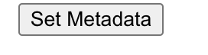

3, The web page contains title, nav bar, connection status, metadata(name, description and image), mint count and mint button.

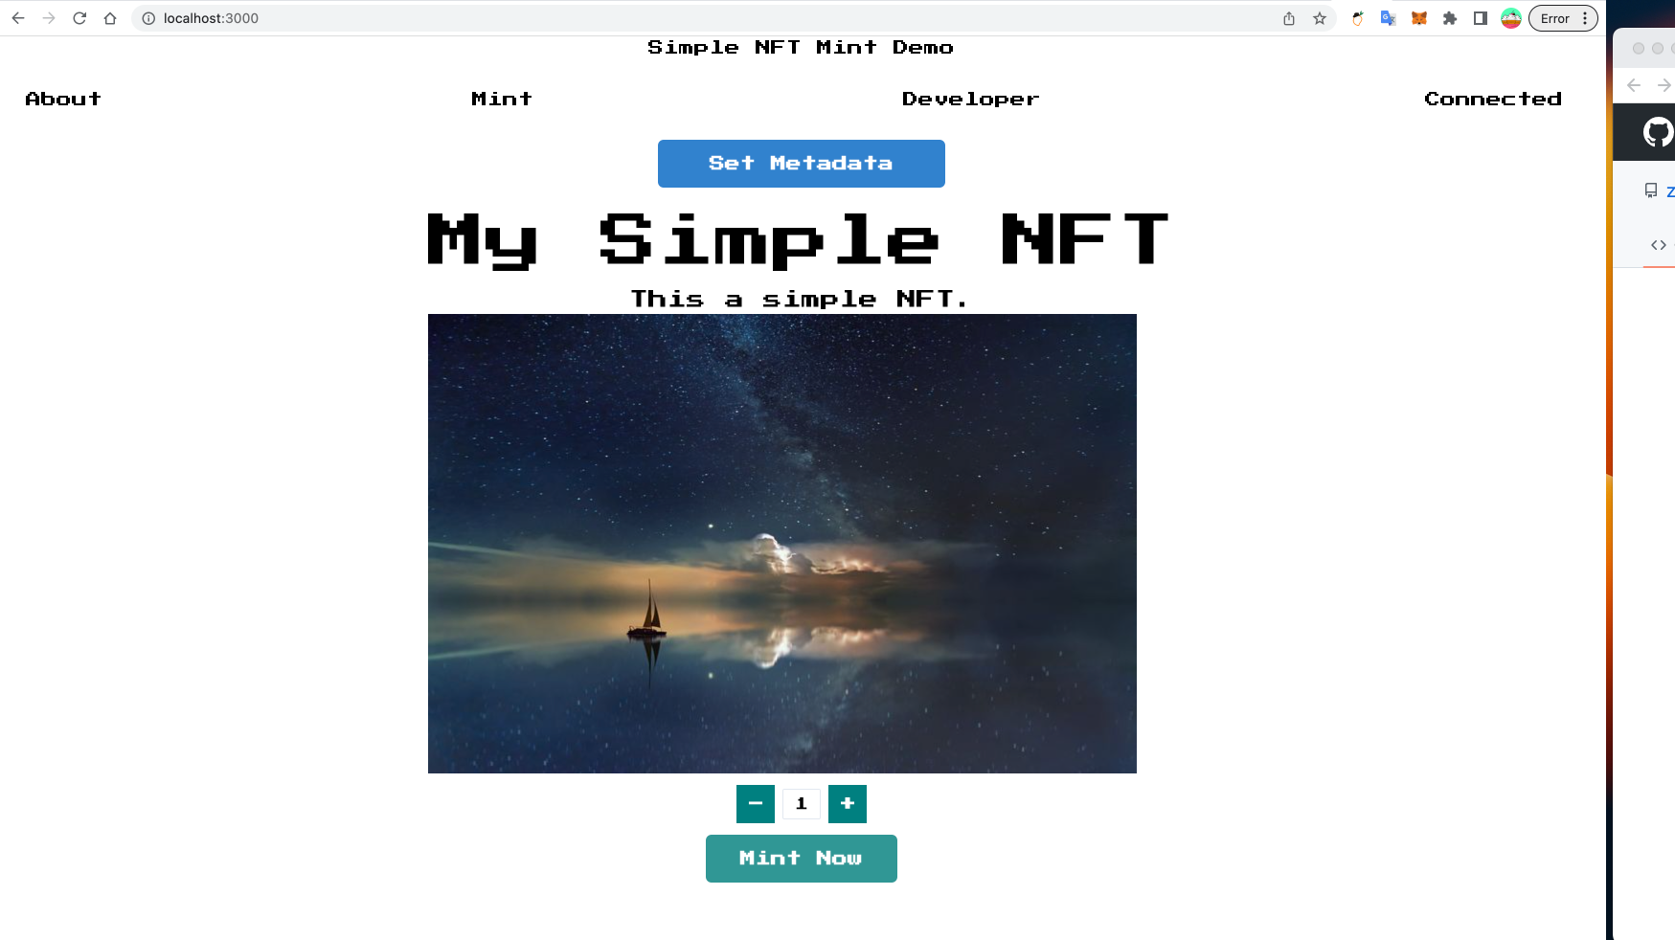

NFT name status

Mint button

Mint Count

NFT Image

NFT description

Connection status

Title

4, select the count of NFT to mint and click NFT button. The metamask will pop up in browser and allow you to acknowledge the transaction.

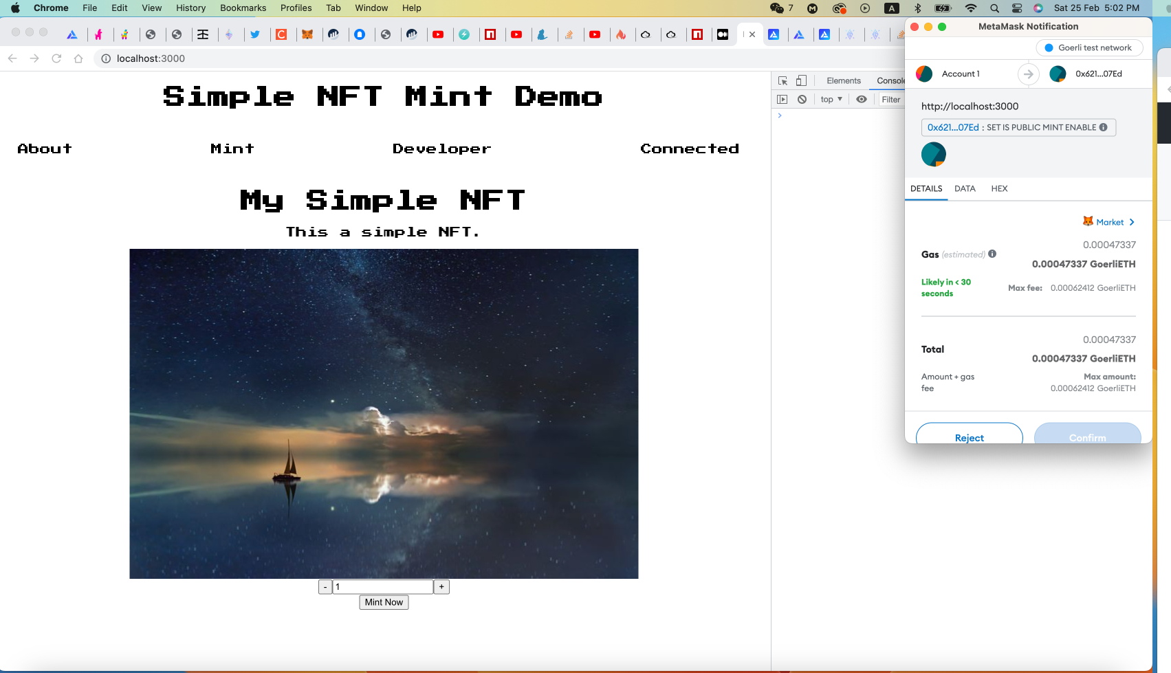

5, Minted successfully.

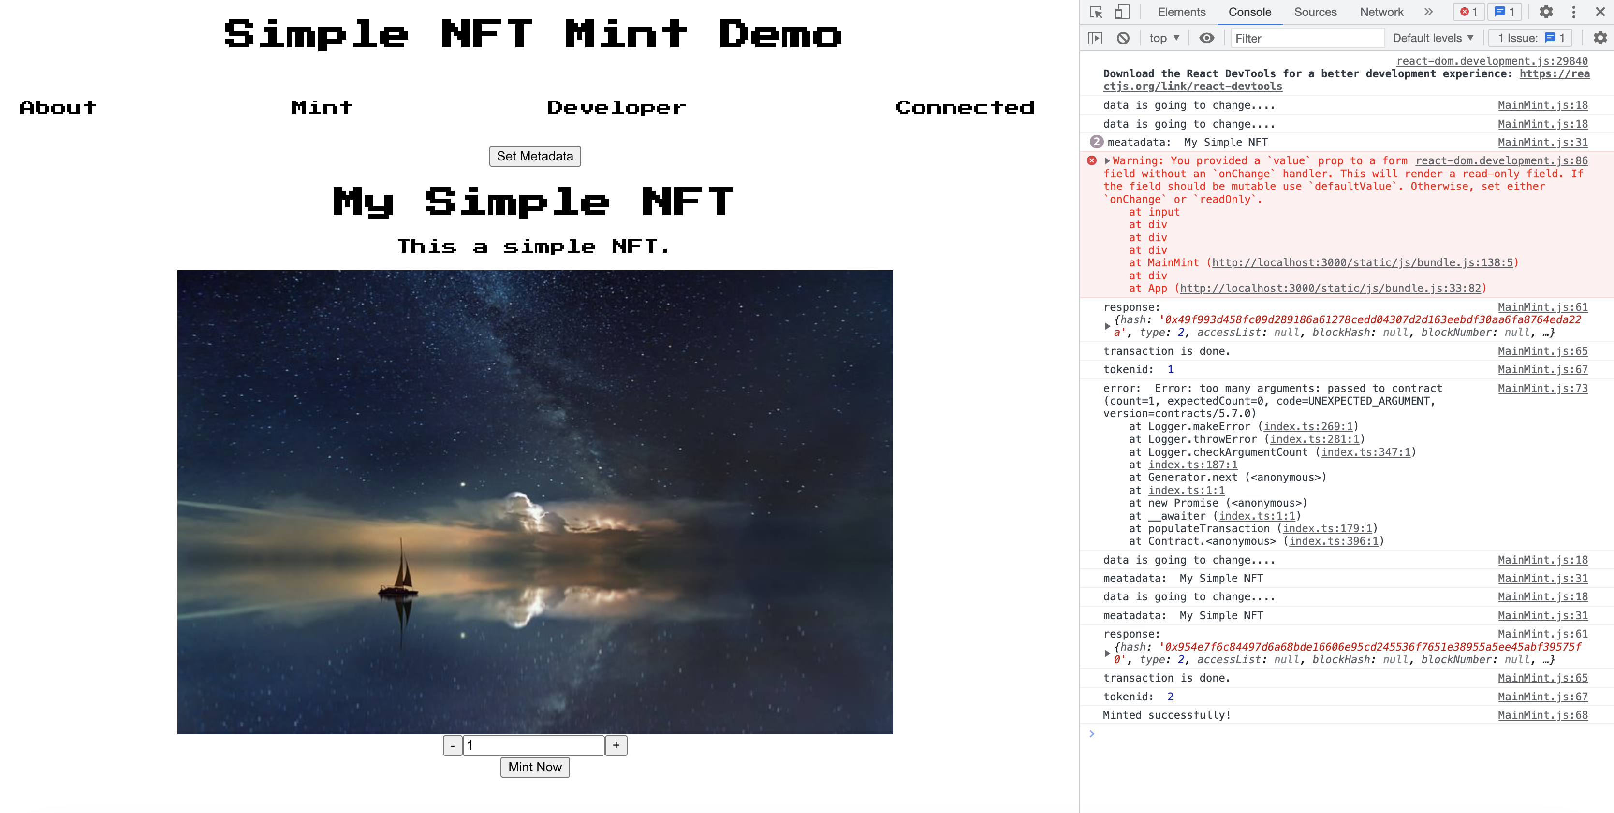

6, Verify the transaction in etherscan goerli website.

